**Assignment No. 9**

**Rohit Pal -2018BTECS00026**

**Abhishek Joshi -2018BTECS00036**

**GRP ID: 2018BCGRP05**

**Date: 22/05/2021**

**Introduction:**

Cassandra is a highly scalable open source database system that achieves great performance when setup with multiple-nodes – even on different data centers.

**Procedure:**

**In each of the folder 1,2 and 3 extracting the zip file of Cassandra:**

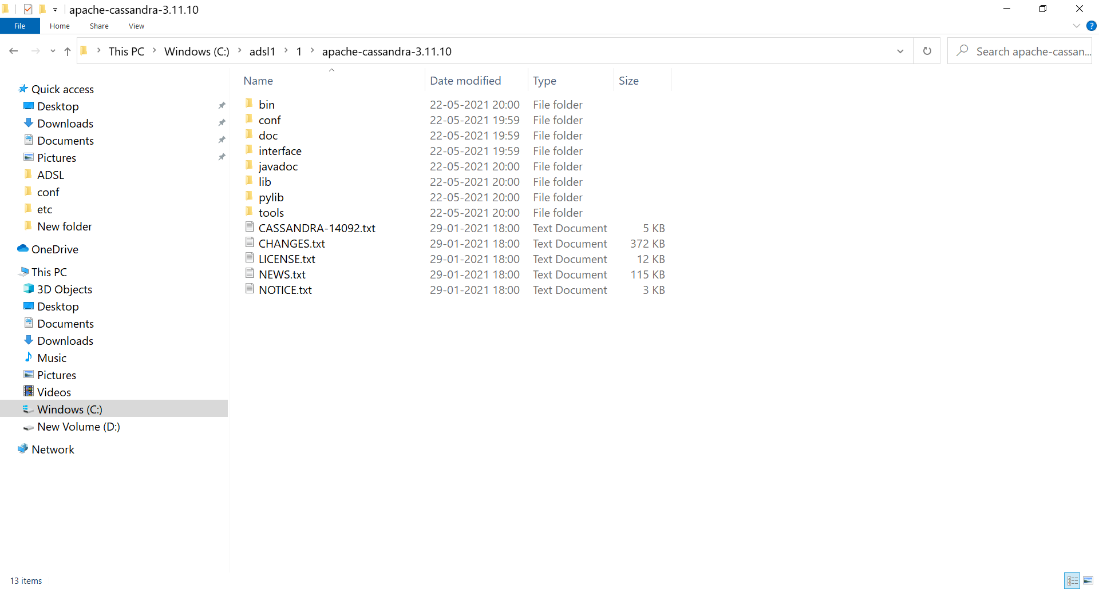

**In Cassandra.yaml file changing cluster name to 2018BCGRP04:**

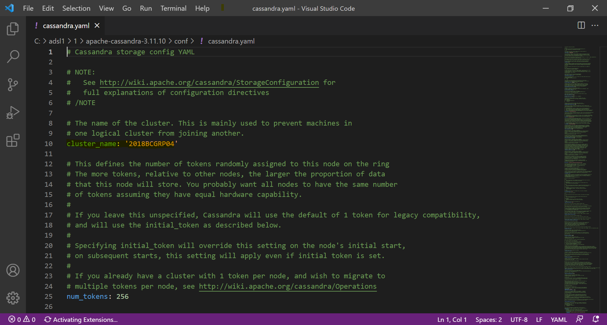

**Running Cassandra.bat file in each of the folders 1,2,3:**

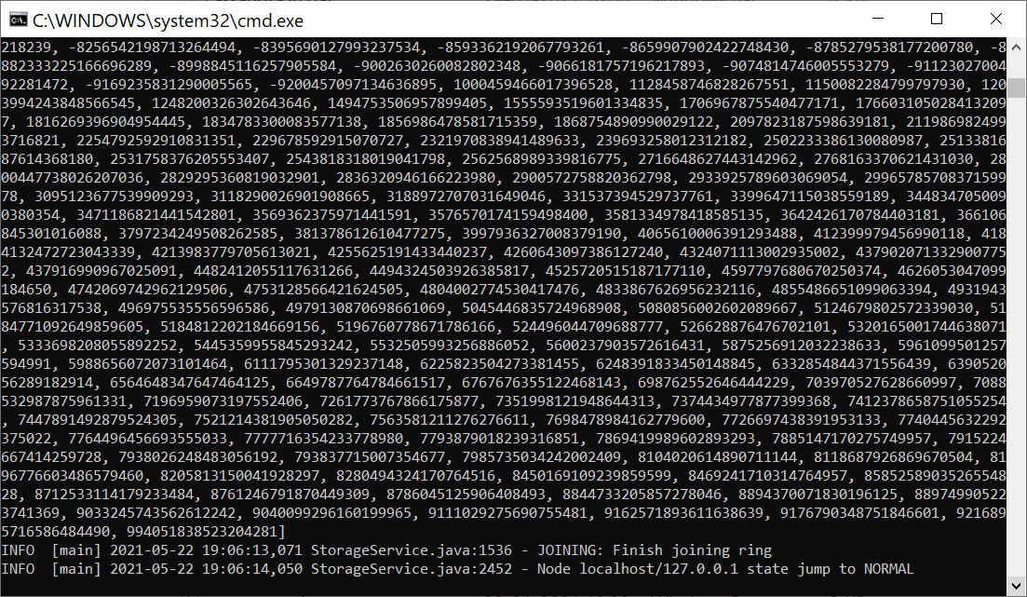

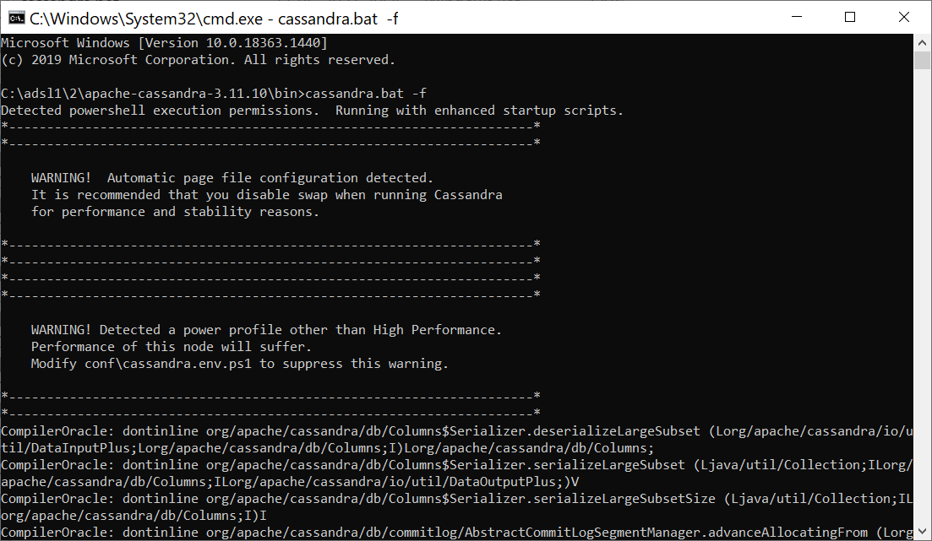

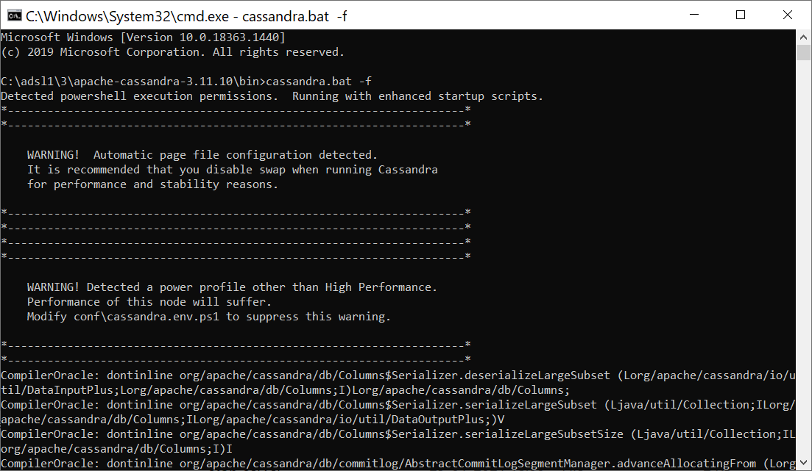

**Results:**

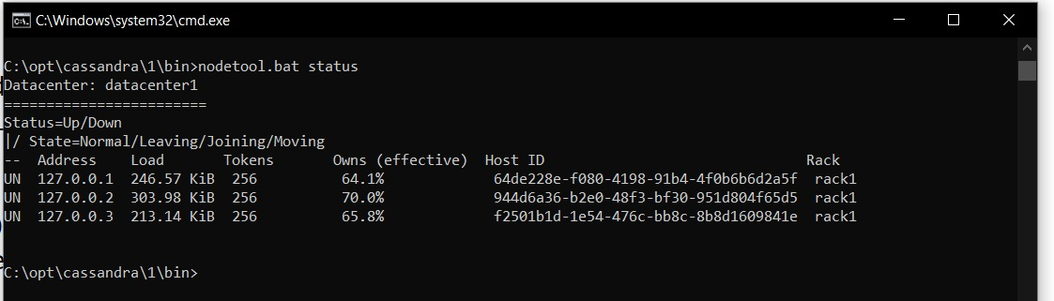

**Conclusion:**

With Cassandra we can achieve great performance when setup with multiple nodes.